Page Projects

Chapter 2

Problems: 2,5,6

Gahana Michele Resignac

CST-161-005-225

Assignment 2

2-You can calculate the surface area of a cube if you know the length of an edge. Write a program that takes the length of an edge (an integer) as input and prints the cube’s surface area as output.

5- An object’s momentum is its mass multiplied by its velocity. Write a program that accepts an object’s mass (in kilograms) and velocity (in meters per second) as inputs and then outputs its momentum.

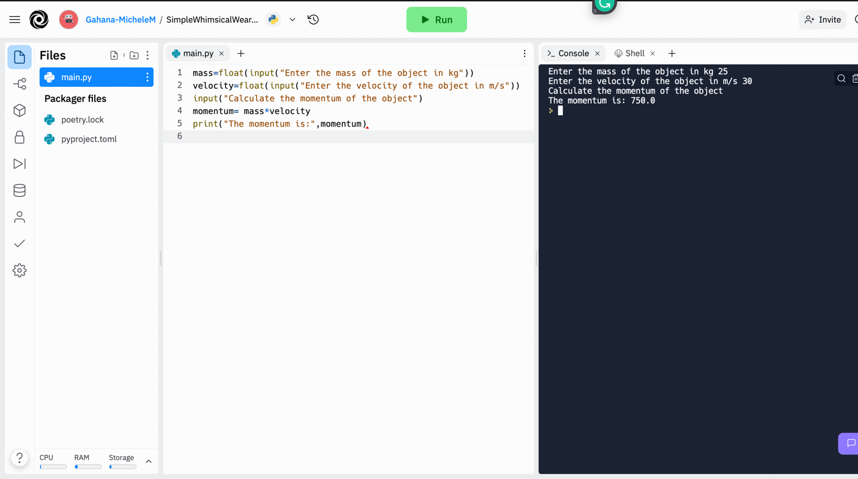

6- The kinetic energy of a moving object is given by the formula KE =( ½)mv2 where m is the object’s mass and v is its velocity. Modify the program you created in Project 5 so that it prints the object’s kinetic energy as well as its momentum.

